George Smith

HW 2: Semistructured Data

# Introduction

The purpose of this assignment was to scrape Semi-structured fundamental financial data, news, and insider trades for all active companies by referencing their individual trading ticker. This assignment is intended to gather various financial information across the web and act as a one stop shop for trading information by simply inputting the relevant ticker of the sought after company.

## Data

The data analyzed is all available information scraped from <https://finviz.com>. Finviz aggregates relevant financial information found all over the web. The attached code will pull real time information related to a company's fundamentals, news, and insider trades, and structure it in a digestible format, so it can be used for trading decisions.

* Fundamentals - Shows 12 Fundamental Ratios in real time including:
  + Attributes
  + Index
  + Market Cap
  + Income
  + Sales
  + Book/sh
  + ATR
  + Volatility
  + Prev Close
  + Price
  + Change
* News - Shows the most recent news related to a company including:
  + Date
  + Headline
  + Article Link
* Insider Trades - Shows information related to the most recent insider trades including:
  + Trader
  + Relationship
  + Date
  + Transaction
  + Cost
  + # Shares
  + Values 4

## Code

The code utilizes the Pandas, Numpy, Beautiful Soup, and Urlib.Request packages.



Because I wanted this code to be able to reference all active tickers I chose to not pull random tickers into a data frame, but rather created an input that will display the necessary information for the sought after ticker.

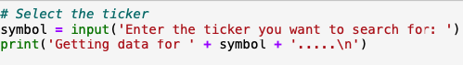

The below code is what I used to pull the fundamental, news and insider trading information from finviz.com

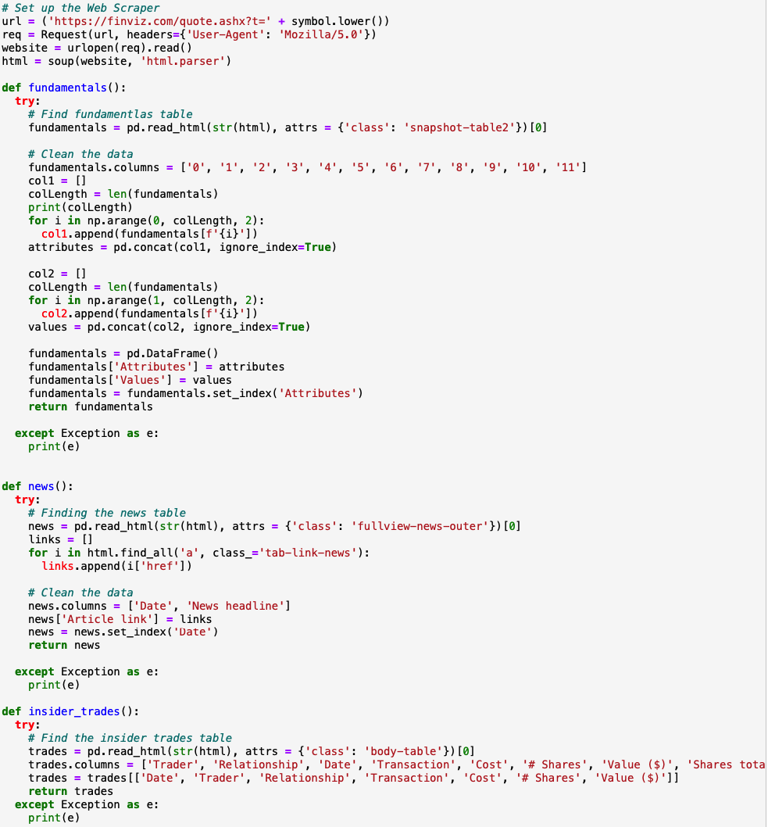

The information is returned using print statements. An example of this output can be found in the Data questions section.

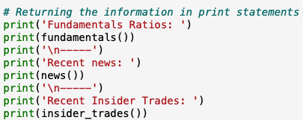

## Data Questions

The discussed code was utilized to answer the following questions:



1. How many news stories are available for Ford as of March 6, 2022
2. How many instances of insider trading have taken place in the past week (Feb 28 - March 6, 2022) for Ford ?

**Question 1:**

One article has been posted regarding Ford as of March 6, 2022. The article can be found at Fool.com and it was posted at 1:33 AM. This appears logical as financial news is not typically updated when markets are not open. It would be expected that more articles would be seen on weekdays. This can be seen in the same output as it looks like multiple articles were posted regarding Ford on March 4, 2022 which was a Friday ( trading day).

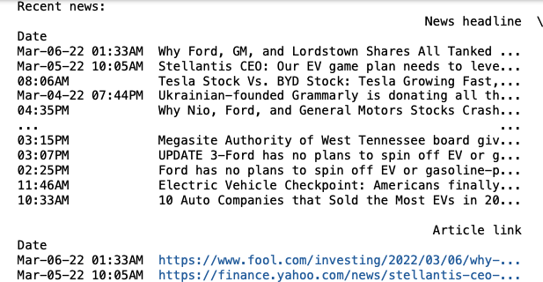

**Question 2:**

The below output depicts two instances of insider trading taking place in the week of February 28 - March 6, 2022) for Ford. Both instances of insider trading are related to James D Farley JR, who has the title of president and CEO. The transactions consisted of an option exercise and general stock sale. The quantities were very large consisting of values of $1,484,373 and $3,308,929 respectively.

